Fundamental Data types vs Immutability:

Data types:

* INT
* FLOAT
* BOOL
* STR
* COMPLEX

IMMUTABILITY:

Mutable - Changeable

Mutable Objects are of type list,[dict](https://www.geeksforgeeks.org/python-dictionary/), or [set](https://www.geeksforgeeks.org/sets-in-python/). Custom classes are generally mutable.

Objects can be modified any time but address will be same.

Immutable – Non-Changeable

* All fundamental data types are immutable
* Once we create an object , we can’t perform any changes in that object.
* If we are trying to perform any changes , with those changes new object will be created

Example:

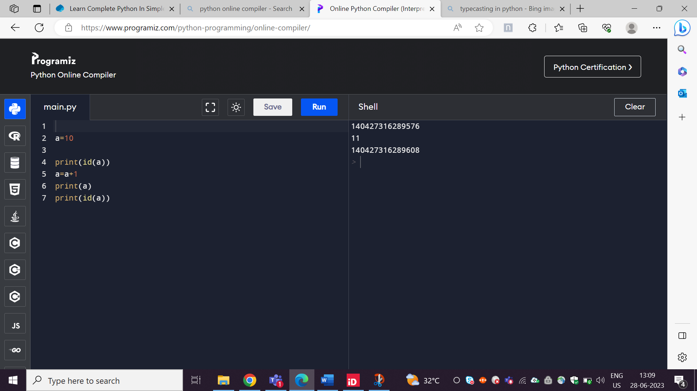

a=a+1

Eligible for garbage collection

11

10

a

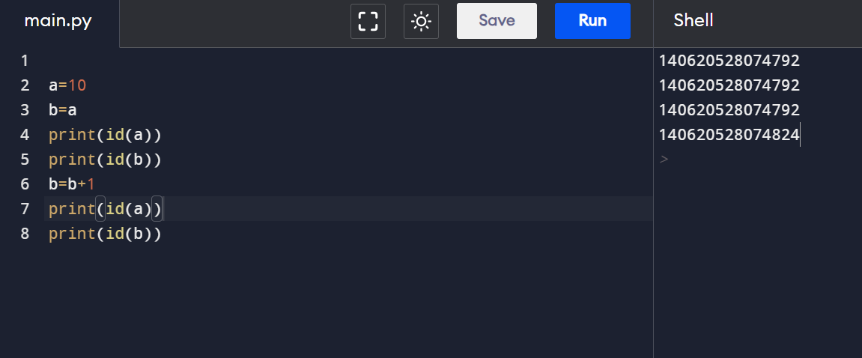

Same address for a and different address for b

Same address for a and b

11

B=b+1

10

A

b

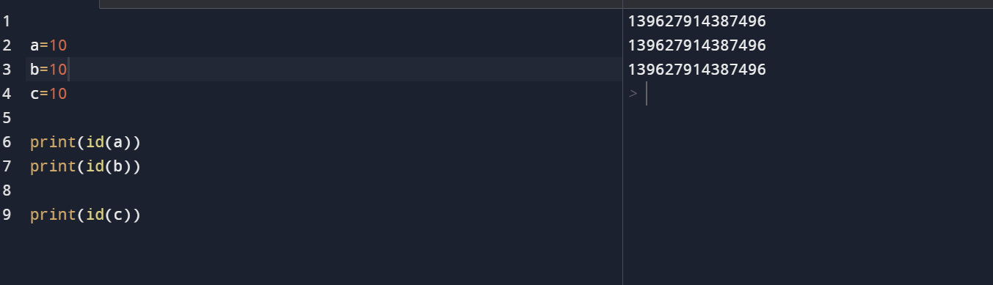

Object Reusability Advantages:

* Memory utilization
* Performance improvement